Data Analytics on Car Wash Business Model

Index

Description

Data & Problem Context

Plan

Design

Implementation

Code with Explanation

Output Screenshots

Closure

1. Description

Project Title:

Customer & Sales Analysis of a Car Wash Business

This project delivers data-driven insights into a car wash business using transaction records. It analyzes sales, customer retention, seasonal demand, and service performance while also visualizing time-of-day trends and carbon footprint.

2. Data & Problem Context

**Problem Statement**

How can we maximize revenue and retain valuable customers through data analytics?

Objectives:

Customer churn rate

Service package recommendation

Seasonality trends

Profitability by service

Identify low-sales months

Carbon footprint tracker

Rank the most-used and highest-earning services:

3. Plan

* Load the data
* Preprocess timestamp info
* Analyze churn, seasonality, and low-revenue months
* Visualize findings via pie/bar/line charts
* Use modular architecture for maintainability

4. Design

**Modular Components:**

* CarWashApp: Controls workflow
* CarWashAnalyzer: Performs calculations
* CarWashVisualizer: Generates visual insights

**Data Flow Diagram:**

User

↓

CarWashApp Menu

↓

Preprocessing → CarWashAnalyzer → Insights

↓

CarWashVisualizer → Charts

5. Implementation

**Technologies Used:**

* Language: Python
* Libraries: pandas, matplotlib
* Architecture: OOP
* Data Source: Local CSV

6. Code with Explanation

Main Application (CarWashApp.py)

import pandas as pd

from analysis import CarWashAnalyzer

from visualization import CarWashVisualizer

# Dataset path

DATA_PATH = r"C:\LEARNING\sic_pu_june25\hackathon\car_wash data set\car_wash_final_dataset_with_date (1).csv"

class CarWashApp:

def __init__(self):

self.df = None

self.analyzer = None

self.visualizer = CarWashVisualizer()

def preprocess_data(self):

print("\nPreprocessing data...")

self.df = pd.read_csv(DATA_PATH, parse_dates=["Transaction Date & Time"])

self.df['Month'] = self.df['Transaction Date & Time'].dt.month_name()

self.df['DayOfWeek'] = self.df['Transaction Date & Time'].dt.day_name()

self.df['Hour'] = self.df['Transaction Date & Time'].dt.hour

self.df['Time Slot'] = self.df['Hour'].apply(

lambda h: "Night" if h < 6 else "Morning" if h < 12 else "Afternoon" if h < 18 else "Evening"

)

self.df.to_csv(DATA_PATH, index=False)

self.analyzer = CarWashAnalyzer(self.df)

print("Preprocessing complete.")

def show_menu(self):

while True:

print("\n--- Car Wash Analysis Menu ---")

print("1. Analyze Customer Churn")

print("2. Recommend Service Packages")

print("3. Analyze Seasonality")

print("4. Track Carbon Footprint")

print("5. Identify Low-Sales Month")

print("6. Rank Services")

print("7. Show All Visualizations")

print("0. Exit")

choice = input("Enter your choice: ")

if choice == "1":

self.analyzer.analyze_churn_rate()

elif choice == "2":

self.analyzer.recommend_service_packages()

elif choice == "3":

self.analyzer.analyze_seasonality()

elif choice == "4":

self.analyzer.track_carbon_footprint()

elif choice == "5":

self.analyzer.identify_low_sales_month()

elif choice == "6":

self.analyzer.rank_services()

elif choice == "7":

self.visualizer.show_all_plots()

elif choice == "0":

print("Exiting...")

break

else:

print("Invalid choice. Please try again.")

if __name__ == "__main__":

app = CarWashApp()

app.preprocess_data()

app.show_menu() Analysis Module (analysis.py)

python

Copy

Edit

import pandas as pd

class CarWashAnalyzer:

def _init_(self, df):

self.df = df

def analyze_churn_rate(self):

latest = self.df["Transaction Date & Time"].max()

last_visits = self.df.groupby("Customer ID")["Transaction Date & Time"].max()

churned = (latest - last_visits).dt.days > 60

churn_rate = churned.mean()

print(f"\nCustomer Churn Rate: {churn_rate:.2%}")

churned.name = 'Churned'

churned.to_csv("churn_data.csv")

def recommend_service_packages(self):

top_services = self.df["Service Type"].value_counts().head(3)

print("\nRecommended Service Combos:")

print(top_services)

top_services.to_csv("recommended_packages.csv", header=["Count"])

def analyze_seasonality(self):

seasonality = self.df.groupby("Month")["Amount Paid"].sum()

print("\nSeasonality Trends (Revenue by Month):")

print(seasonality)

seasonality.to_csv("seasonality.csv", header=["Revenue"])

def track_carbon_footprint(self):

emission_factor = 0.05 # kg CO2 per transaction

self.df["CO2_Emitted"] = emission_factor

footprint = self.df.groupby("Month")["CO2_Emitted"].sum()

print("\nMonthly CO2 Emissions (kg):")

print(footprint)

footprint.to_csv("carbon_footprint.csv", header=["CO2_Emitted"])

def identify_low_sales_month(self):

monthly_sales = self.df.groupby("Month")["Amount Paid"].sum()

low_month = monthly_sales.idxmin()

print(f"\nLowest Sales Month: {low_month} – ₹{monthly_sales[low_month]:,.2f}")

monthly_sales.to_csv("monthly_sales.csv", header=["Revenue"])

def rank_services(self):

ranking = self.df.groupby("Service Type").agg(

Usage_Count=("Transaction ID", "count"),

Total_Revenue=("Amount Paid", "sum")

).sort_values("Total_Revenue", ascending=False)

print("\nService Ranking by Revenue and Usage:")

print(ranking)

ranking.to_csv("service_ranking.csv")

📈 Visualization Module (visualization.py)

python

Copy

Edit

import pandas as pd

import matplotlib.pyplot as plt

import os

class CarWashVisualizer:

def plot_churn_rate(self):

data = pd.read_csv("churn_data.csv", index_col=0).squeeze()

counts = data.value_counts()

counts.index = ["Active", "Churned"]

counts.plot(kind="pie", autopct='%1.1f%%', title="Customer Churn Rate")

plt.ylabel('')

plt.tight_layout()

plt.show()

def plot_service_recommendations(self):

data = pd.read_csv("recommended_packages.csv", index_col=0).squeeze()

data.plot(kind="bar", color="skyblue", title="Top Recommended Services")

plt.xlabel("Service Type")

plt.ylabel("Count")

plt.tight_layout()

plt.show()

def plot_seasonality(self):

data = pd.read_csv("seasonality.csv", index_col=0).squeeze()

data.plot(kind="line", marker='o', title="Seasonality Trends")

plt.xlabel("Month")

plt.ylabel("Revenue")

plt.grid(True)

plt.tight_layout()

plt.show()

def plot_carbon_footprint(self):

data = pd.read_csv("carbon_footprint.csv", index_col=0).squeeze()

data.plot(kind="bar", color="olive", title="Monthly CO2 Emissions")

plt.xlabel("Month")

plt.ylabel("CO2 (kg)")

plt.tight_layout()

plt.show()

def plot_low_sales_month(self):

data = pd.read_csv("monthly_sales.csv", index_col=0).squeeze()

low = data.idxmin()

colors = ['red' if m == low else 'lightgrey' for m in data.index]

data.plot(kind="bar", color=colors, title="Monthly Sales (Lowest Highlighted)")

plt.xlabel("Month")

plt.ylabel("Revenue")

plt.tight_layout()

plt.show()

def plot_service_ranking(self):

df = pd.read_csv("service_ranking.csv", index_col=0)

df["Total_Revenue"].plot(kind="barh", color="seagreen", title="Top Services by Revenue")

plt.xlabel("Revenue")

plt.tight_layout()

plt.show()

df["Usage_Count"].plot(kind="barh", color="dodgerblue", title="Top Services by Usage")

plt.xlabel("Usage Count")

plt.tight_layout()

plt.show()

def show_all_plots(self):

print("\nGenerating all available plots...")

if os.path.exists("churn_data.csv"):

self.plot_churn_rate()

if os.path.exists("recommended_packages.csv"):

self.plot_service_recommendations()

if os.path.exists("seasonality.csv"):

self.plot_seasonality()

if os.path.exists("carbon_footprint.csv"):

self.plot_carbon_footprint()

if os.path.exists("monthly_sales.csv"):

self.plot_low_sales_month()

if os.path.exists("service_ranking.csv"):

self.plot_service_ranking()

7. Output Screenshots

(You can generate these using your app and embed them here.)

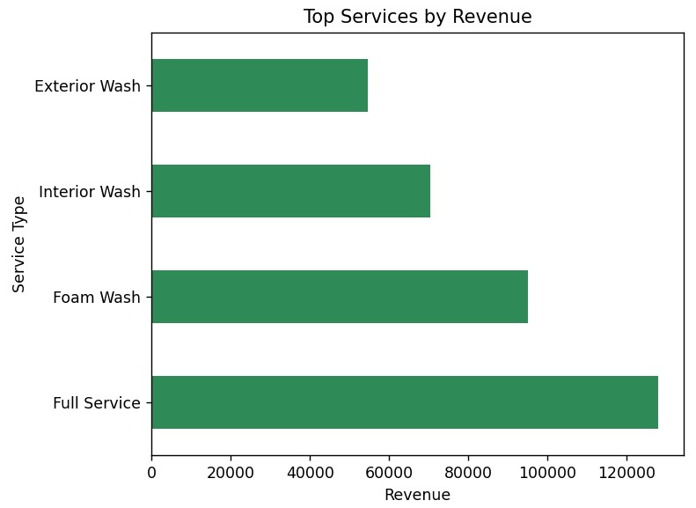

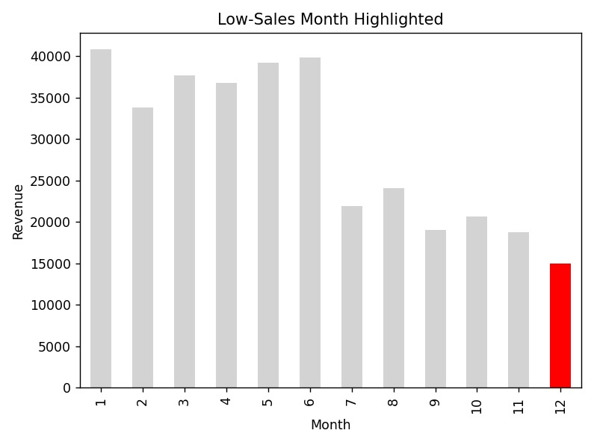

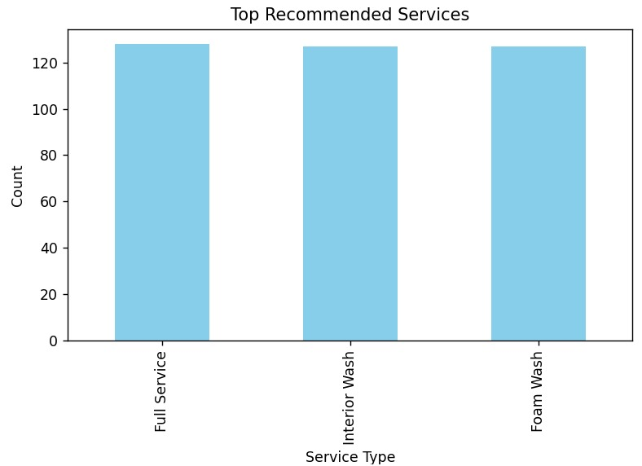

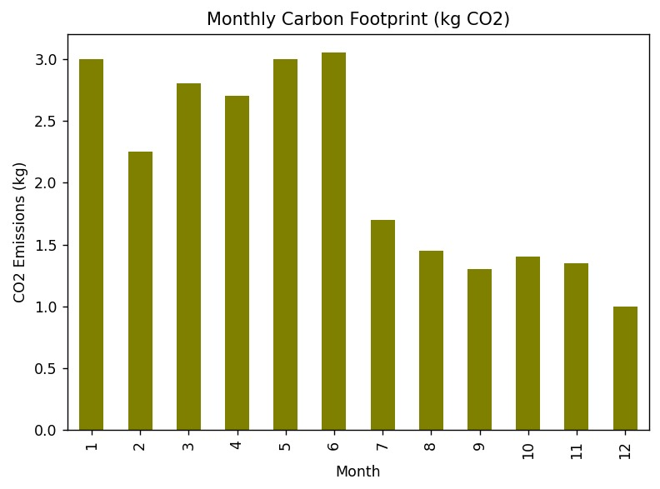

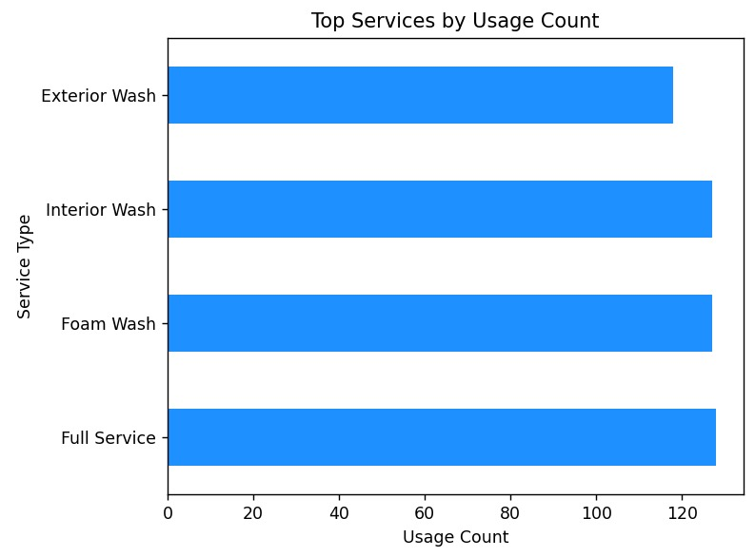

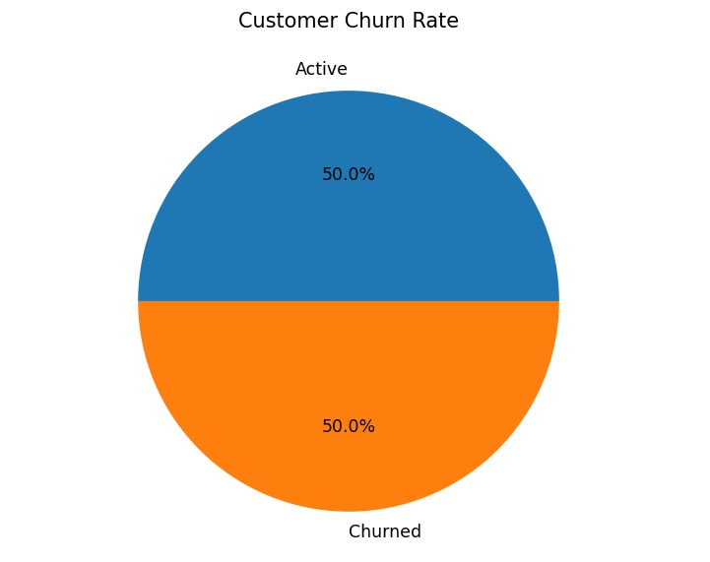

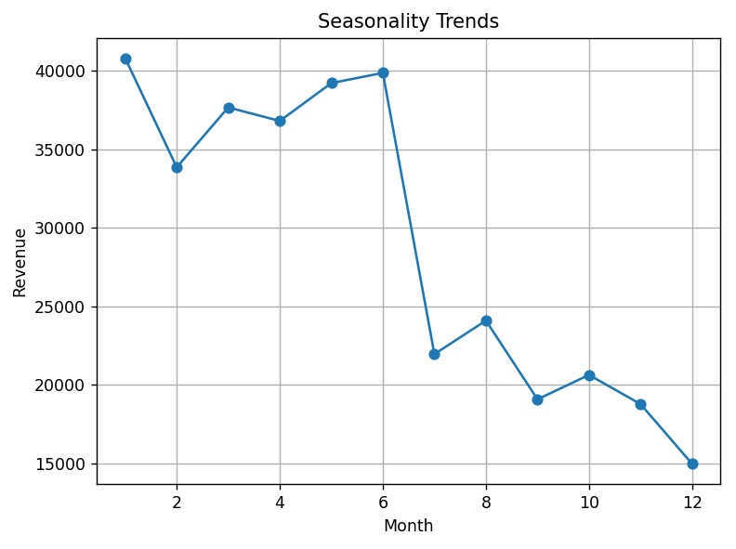

8. Closure

The Car Wash Analytics App helps understand customer behavior, plan promotions, and analyze sales trends. By integrating churn analysis, seasonal trends, and service ranking, it delivers actionable insights with interactive visuals. Future updates could add live customer notification, email-based re-engagement, and real-time dashboards.